Official league roster - Soccer
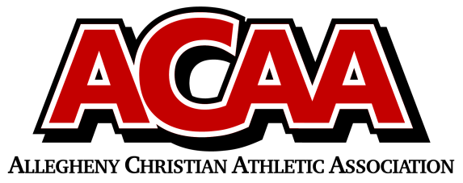

School Name: Blair County Christian
Team Colors: Green and White
Overall Wins ___ Losses ____ Ties ___
ACAA Wins ___ Losses ____ Ties ___ OPPONENT: __________________________
Date: _________
Number | Name | Year | Position | Homeschool
7 | Gabi Dull | 12 | For/Mid
6 | Makayla Huston | 11 | Def/Goalie
4 | Jena Kane | 10 | Def
8 | Johannah Love | 10 | Def
13 | Rylie Oldham | 10 | Def
3 | Ava Snyder | 10 | Mid/Def
16 | Kadee Spinazzola | 10 | For
11 | Calee Kennedy | 9 | Mid
2 | Allison Hall | 8 | Mid | yes
15 | Gianna Spinazzola | 8 | Mid/Def
20 | Adalee Bickings | 7 | Goalie/Mid
5 | Tegan Kennedy | 7 | Mid
10 | Allison Focht | 7 | Mid/Def

Head Coach: Chris Davis
Asst. coach: Erica Kennedy
Asst. coach: Rob Miller

Official ACAA League Team Roster. to be submitted to the scorer’s table before each game.

